CLOUD COMPUTING PROJECT

Capstone Project:

Create a Chat bot using Amazon Lex Tool.

Intent of the chat bot:Book Hotel

1)All the information must be conveyed to the user after booking room and must be informed to the user the price of the hotel room and day of stay .

2)Using this chat bot user must aware of types of Available rooms

(Classic,Duplex etc)-Choose your own Category as well.

3)All events must be in flow for fulfilment of the intent .

Step 1: Log in to AWS Console:

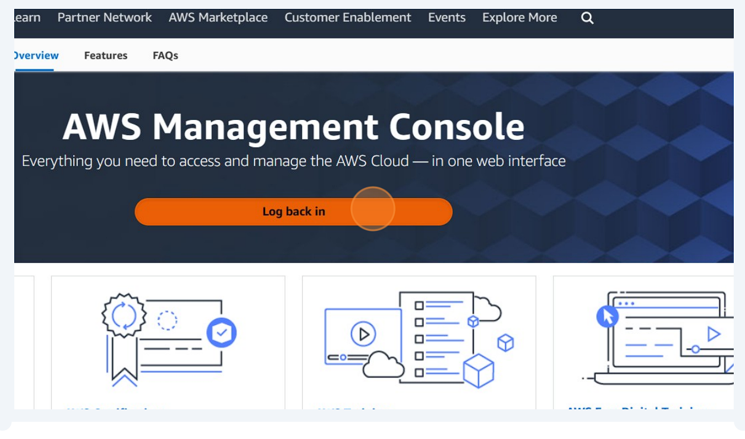

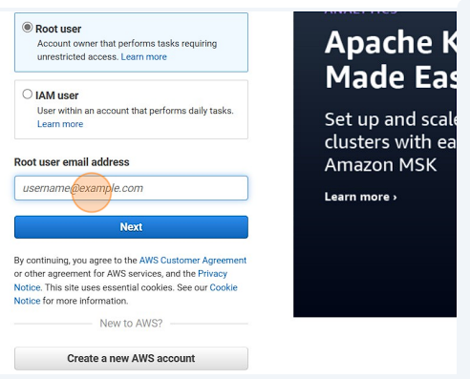

Step 2:Search for Amazon Lex

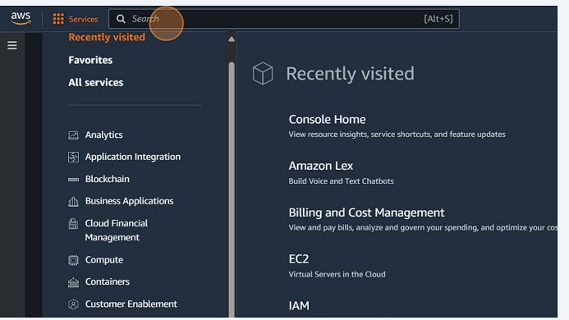

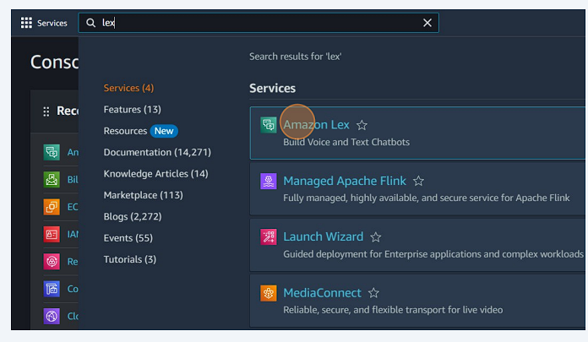

Step 3: Click on Create Bot

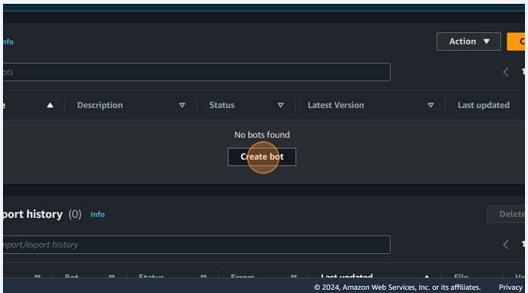

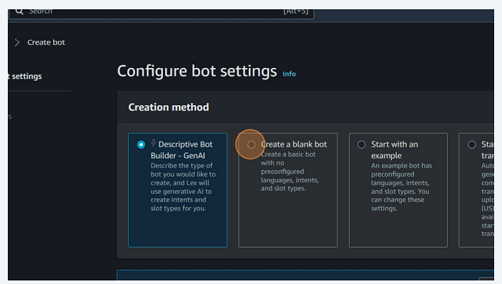

Step 4: Bot Configuration

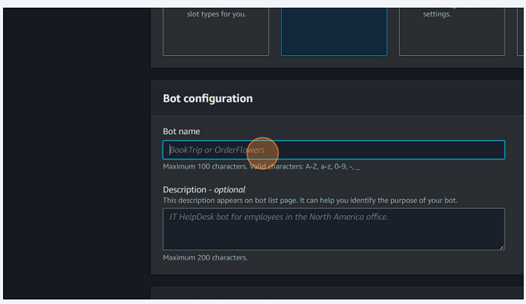

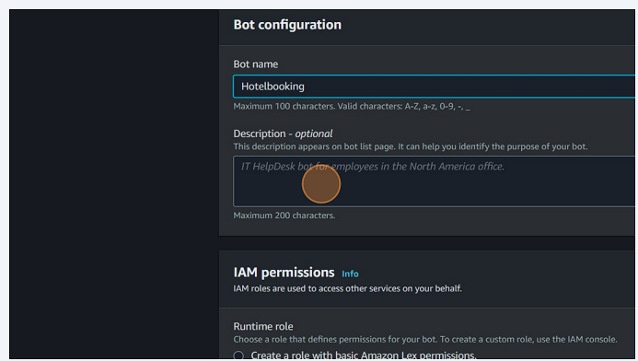

Step 5: IAM permissions

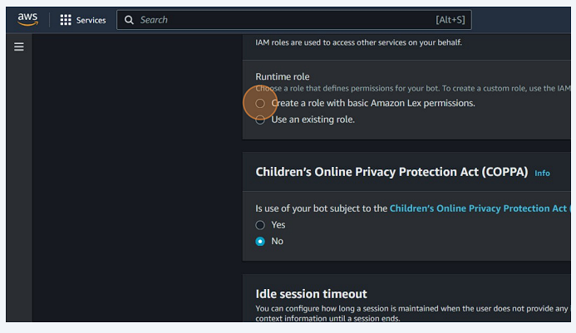

Step 6: Select “No” on Children’s Online Privacy Protection Act (COPPA)

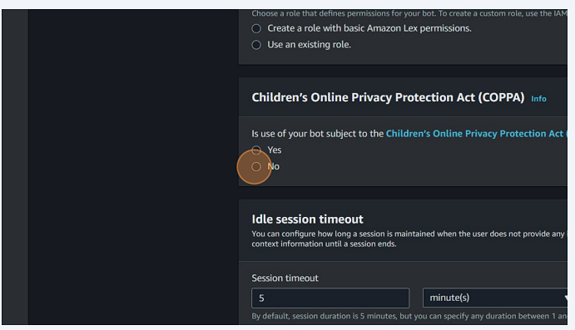

Step 7: Configure the Idle Session Timeout.

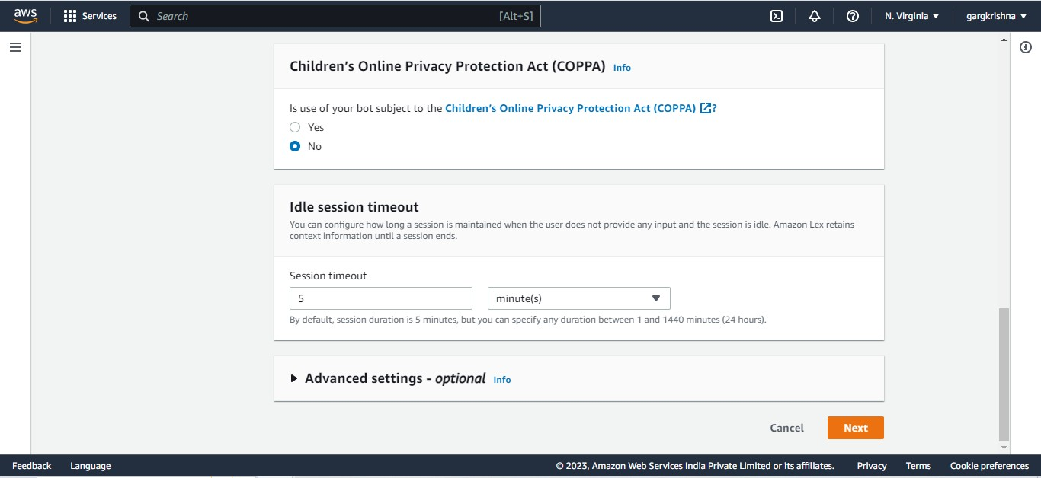

Step 8: Add Language to the Bot

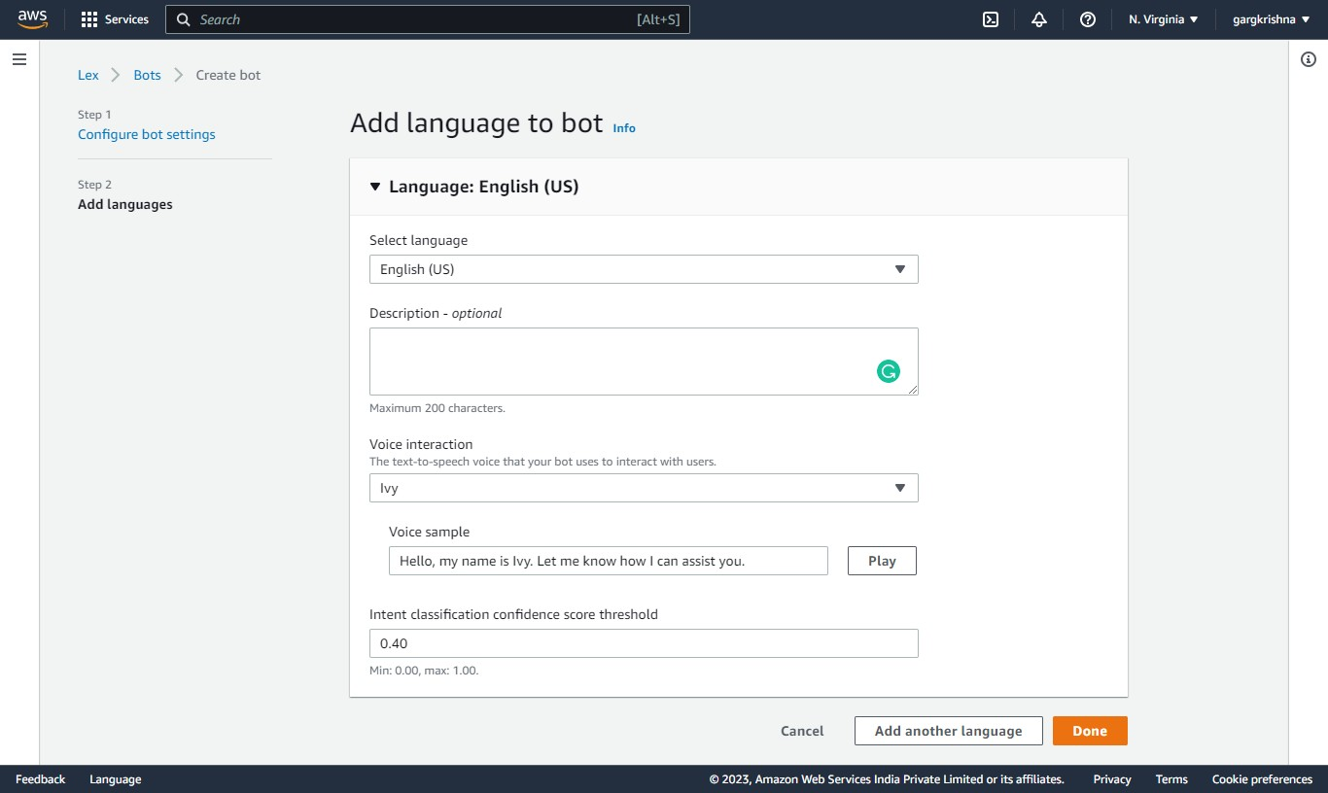

Step 9 : A bot is named as “HotelBooking”created successfully

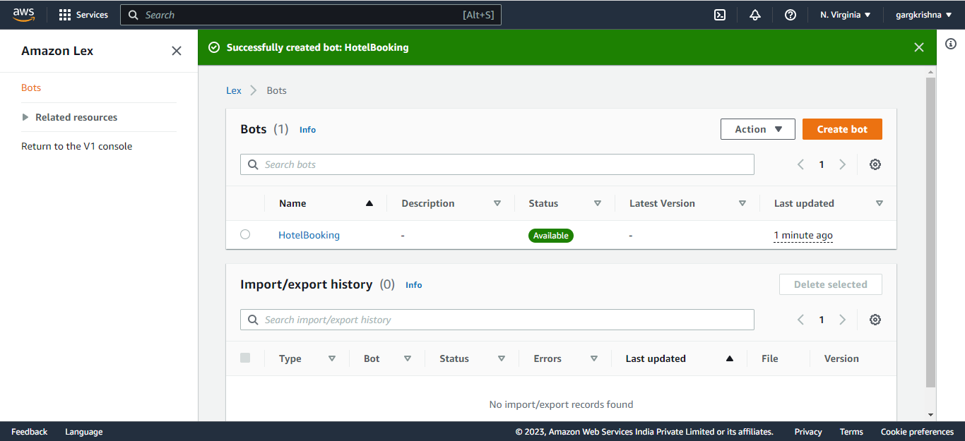

Step 10: Click on “HotelBooking” and configure the intent details

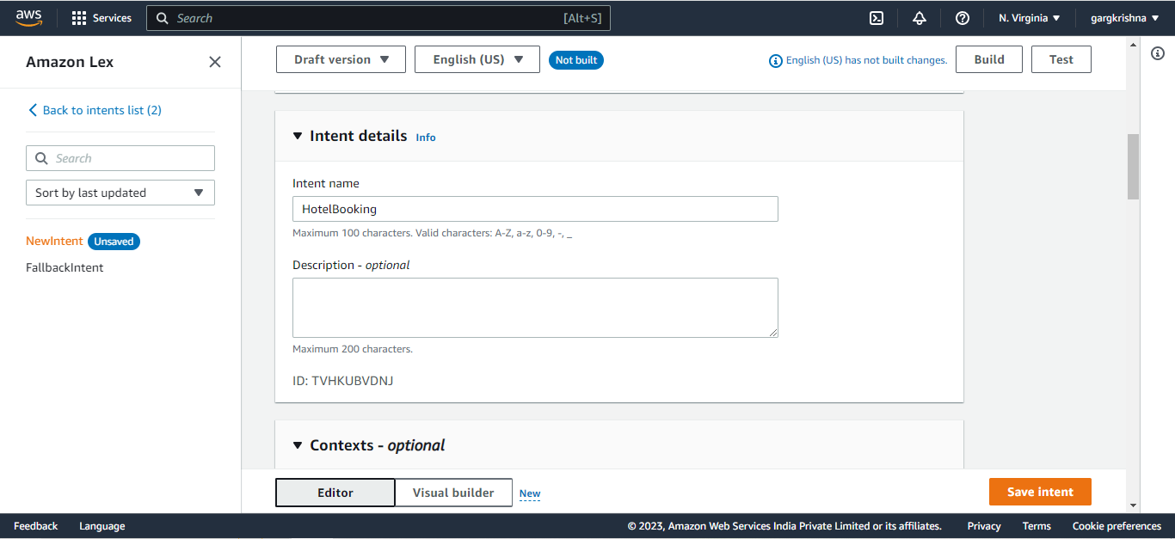

Step 11: Add Sample Utterances related to Hotel Booking

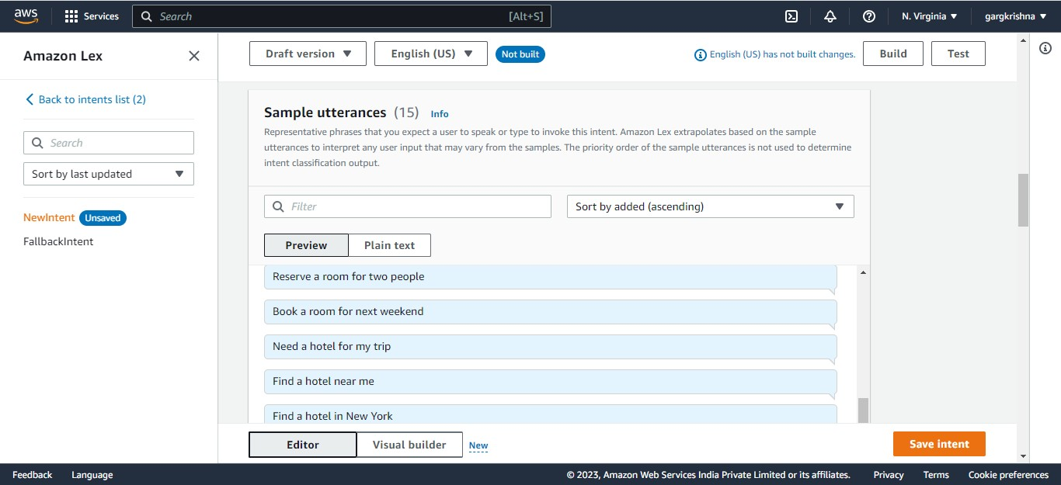

Step 12: Configure Initial Response

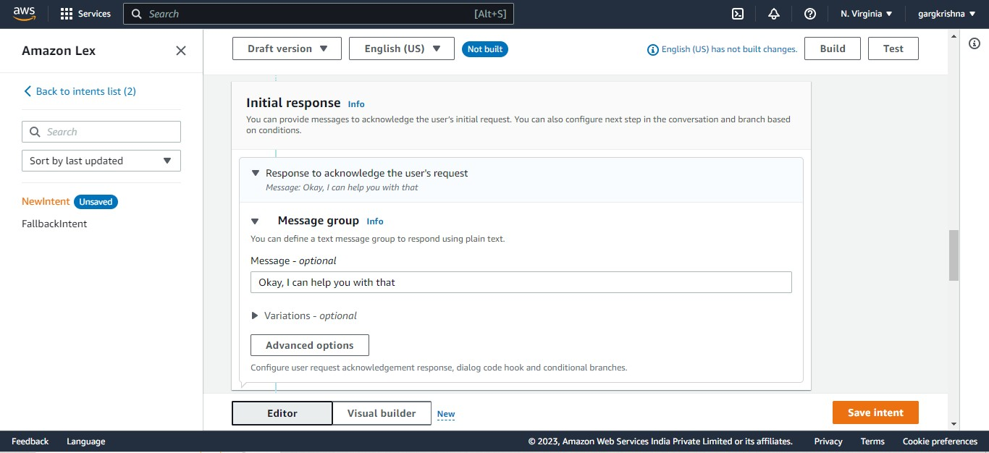

Step 13: Configure Slots

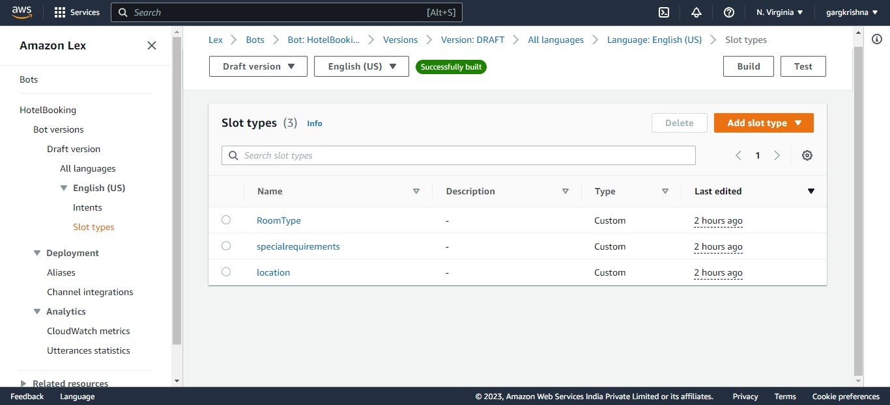

Step 14: Adding Buttons in Room Type

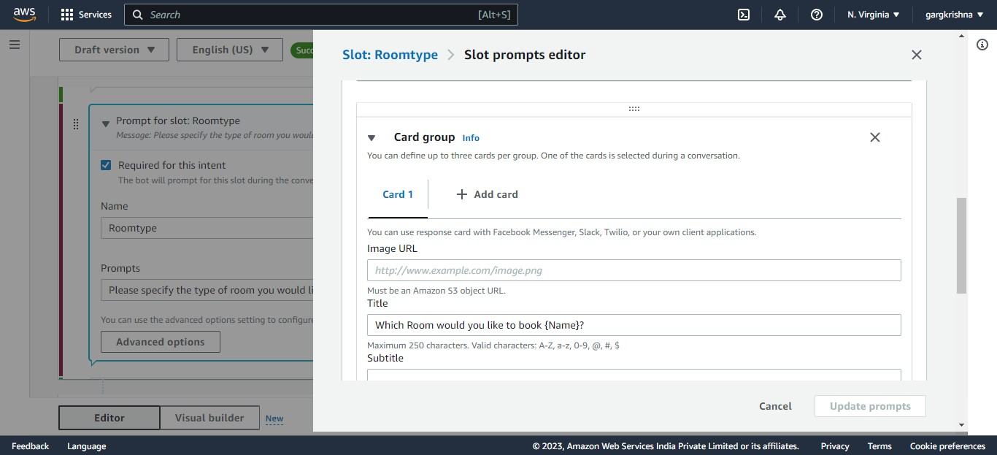

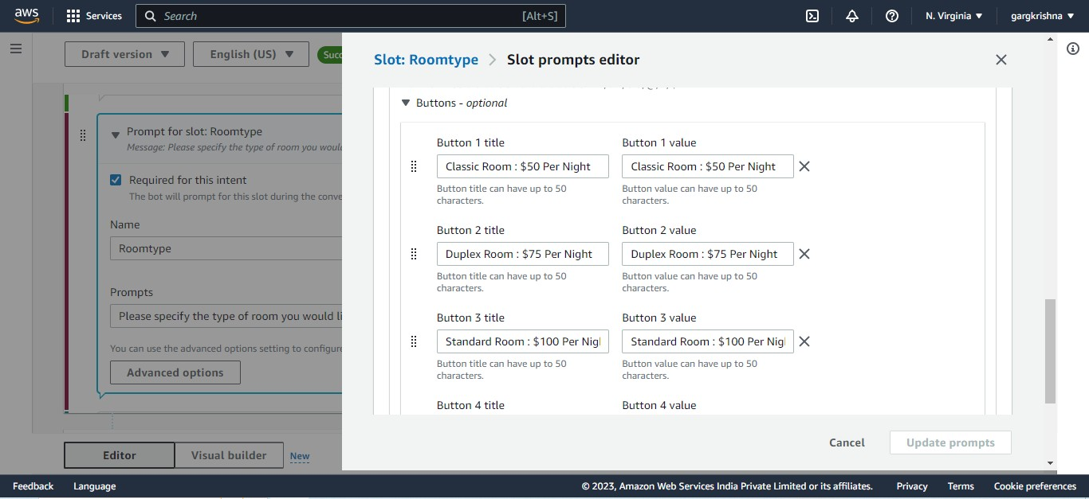

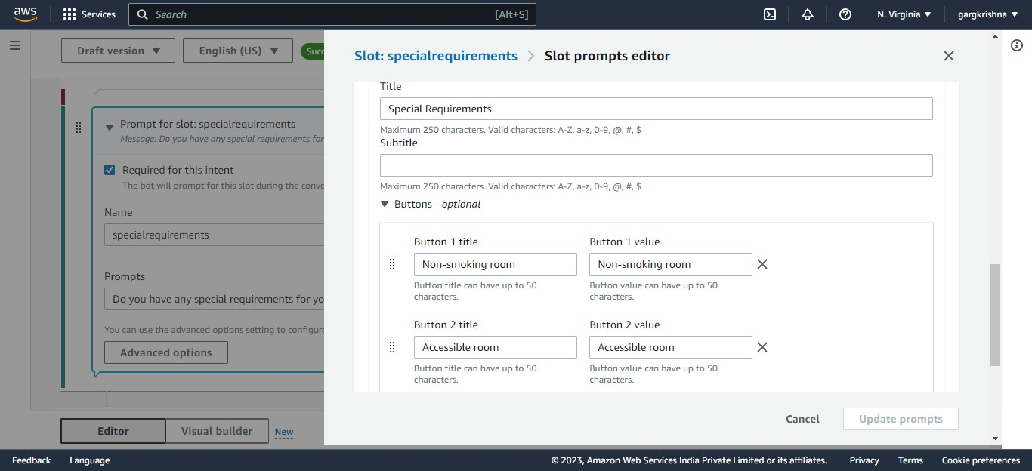

Step 15: Configuring Confirmation

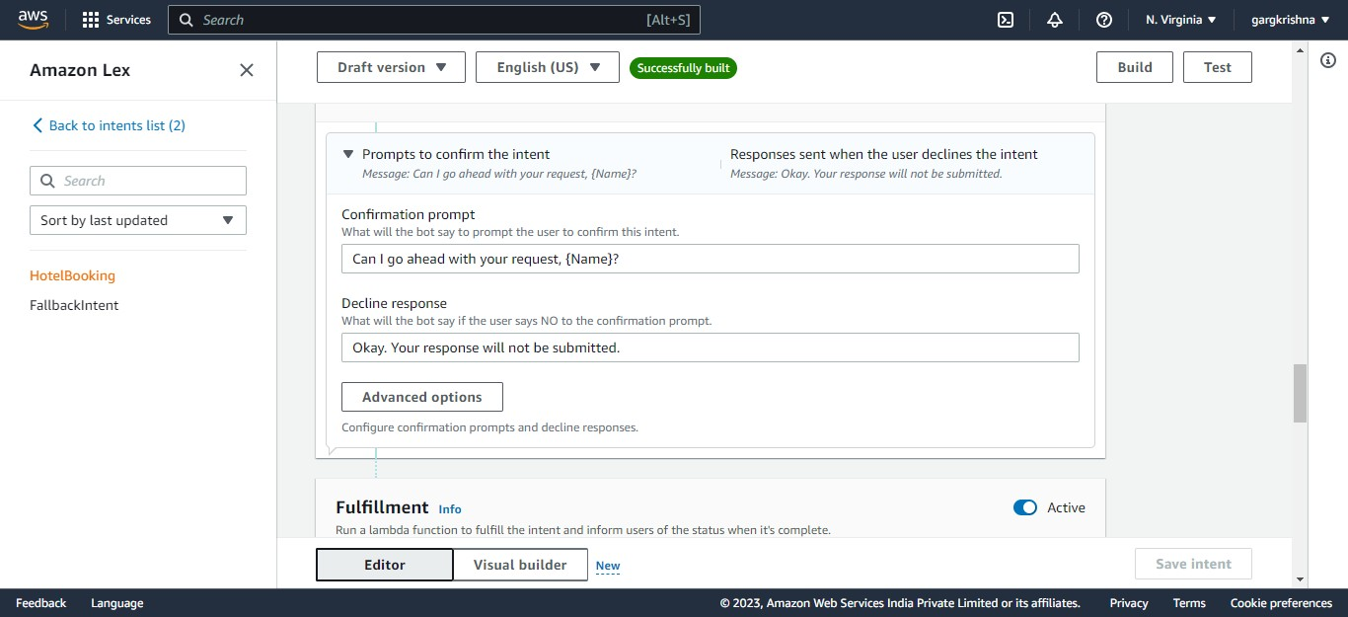

Step 16: Configuring Fulfillment

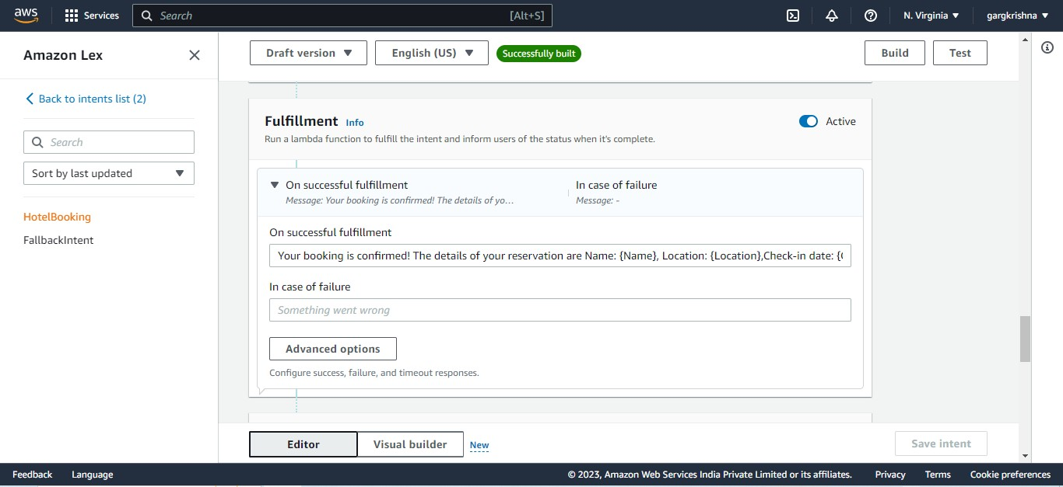

Step 17: Configuring Closing Response

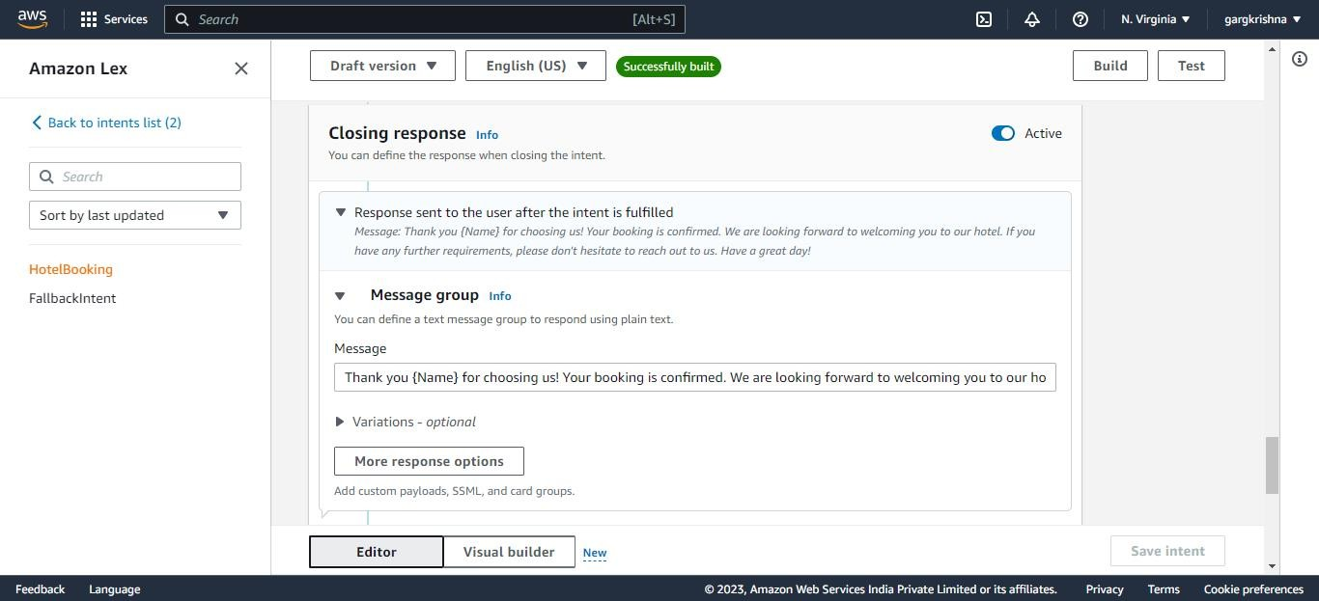

Step 18: Click the Build

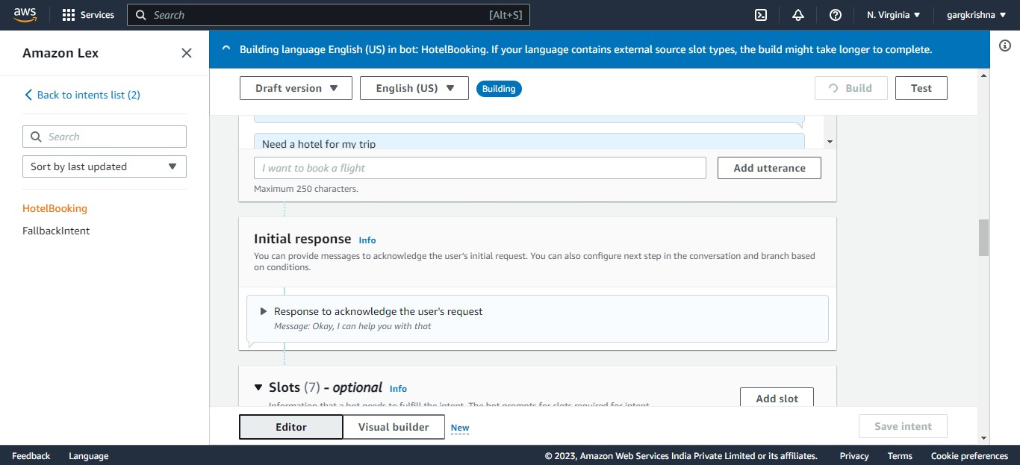

Step 19: Successfully Build a Bot

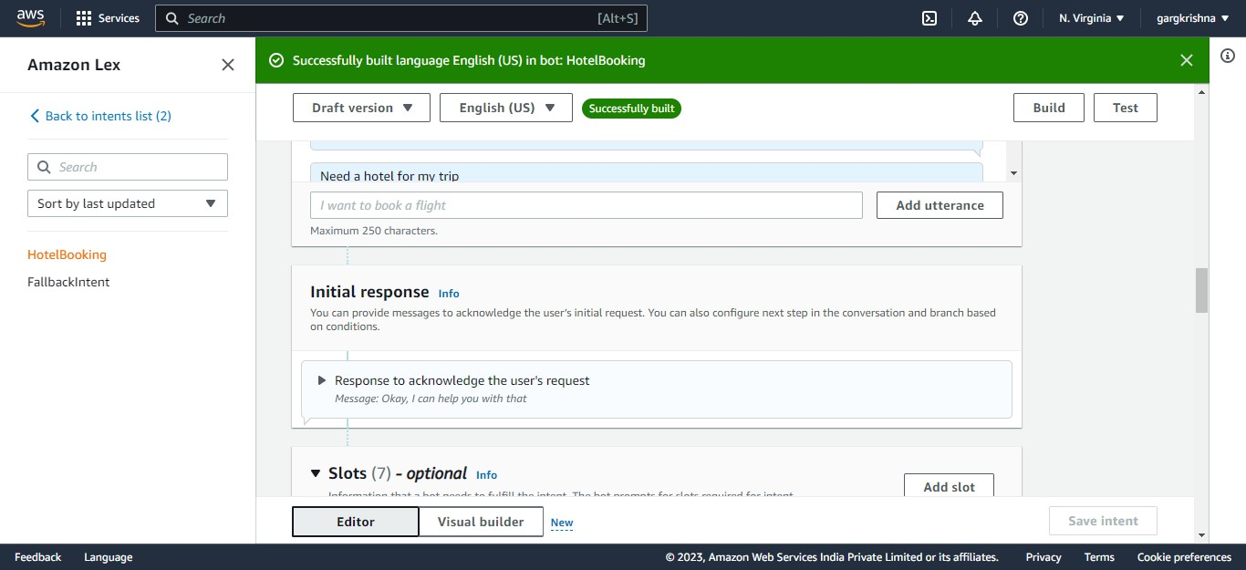

Conversation to the Bot

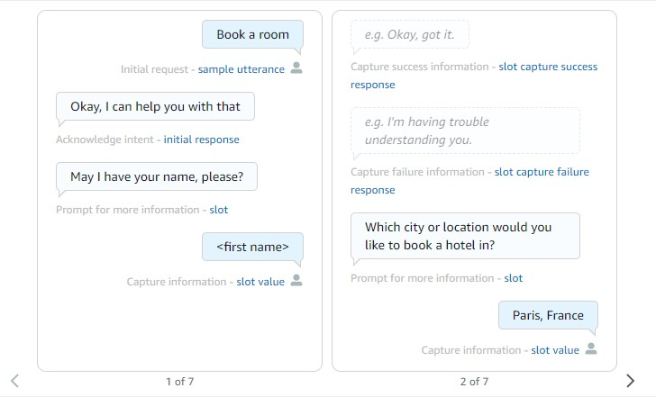

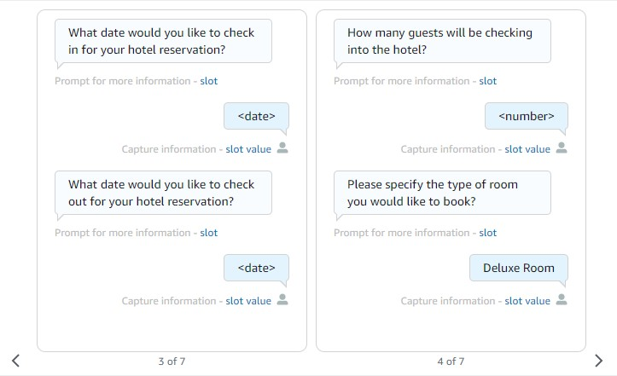

Chat box video using Amazon Lex-

https://drive.google.com/file/d/1ZV67NGgJax9s2irx-A73lmbXpO4bsnre/view?usp=drive_link

Sample Source Code

Here’s a basic example of how you can define the intents and slots in Amazon Lex:

{

"intents": [

{

"name": "BookHotel",

"slots": [

{

"name": "RoomType",

"slotType": "RoomType",

"slotTypeVersion": "1",

"valueElicitationPrompt": {

"messages": [

{

"contentType": "PlainText",

"content": "What type of room would you like to book? (Classic, Duplex, etc.)"

}

],

"maxAttempts": 2

},

"priority": 1

},

{

"name": "CheckInDate",

"slotType": "AMAZON.DATE",

"valueElicitationPrompt": {

"messages": [

{

"contentType": "PlainText",

"content": "What is your check-in date?"

}

],

"maxAttempts": 2

},

"priority": 2

},

{

"name": "CheckOutDate",

"slotType": "AMAZON.DATE",

"valueElicitationPrompt": {

"messages": [

{

"contentType": "PlainText",

"content": "What is your check-out date?"

}

],

"maxAttempts": 2

},

"priority": 3

},

{

"name": "NumberOfGuests",

"slotType": "AMAZON.NUMBER",

"valueElicitationPrompt": {

"messages": [

{

"contentType": "PlainText",

"content": "How many guests will be staying?"

}

],

"maxAttempts": 2

},

"priority": 4

}

],

"fulfillmentActivity": {

"type": "ReturnIntent"

}

}

],

"slotTypes": [

{

"name": "RoomType",

"description": "Types of rooms available",

"enumerationValues": [

{

"value": "Classic"

},

{

"value": "Duplex"

},

{

"value": "Suite"

}

]

}

]

}